Raining Cats and Dogs!?

You might have heard the saying, “It’s raining cats and dogs.”
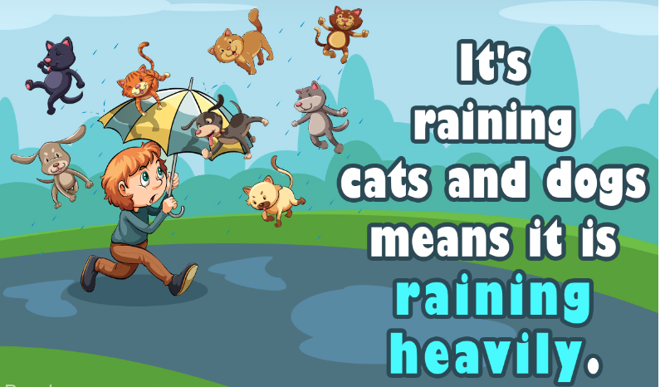
If you could make it rain any two things you wanted, what would you choose?

• Write about your special rainstorm. What would be falling from the clouds and why?
• Draw a picture of it.

How can you start your sentence?
-I want it to rain ______________ because____________.
-In a rainstorm I wish it would rain__________________.

